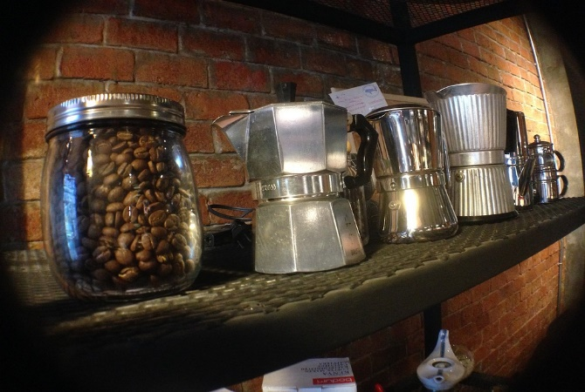

**Activity 3**



**Coffee is the beverage brewed from roasted coffee beans. Darkly colored , bitter , and slightly acidic , coffee has a stimulating effect on humans , primarily due to**

**Its caffeine content. Its has the highest sales in the world market for hot drinks.**